The gathering of a large group of people in social media has established a certain framework of what is normal. The power of social media urges people to take drastic actions and justify it with other’s acceptance. Sometimes the interactions through social media may convince someone that their wrongs may be right and persuade them to inflict further harm on others while at other times people tend to take drastically great actions for the better cause. The internet sensation Rebecca Black faced the consequences of the negative populace of social media. Her experience with social media reveals the treacherous judgement that these people possess. On the other hand, the “dancing man” Sean O’Brien faced the more positive side of the internet. The experiences of these two people vary greatly, but show just how connected the people of social media are.

The sheer population of active facebook users consist of over 1 billion people. This provides for an immense enough population that it would be the third largest country in the world. People begin to



<http://www.clipartbest.com/cliparts/Kij/gMg/KijgMg85T.gif>



https://www.snapchat.com/global/social-lg.jpg

<https://www.youtube.com/yt/brand/media/image/YouTube-logo-full_color.png>

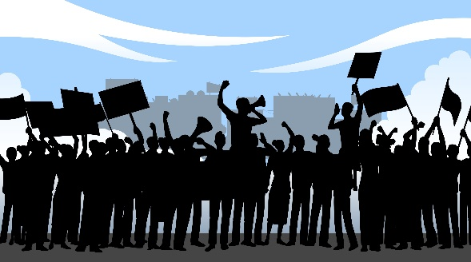

<http://riaclu.org/images/uploads/Protesters.jpg>



http://orig13.deviantart.net/4479/f/2008/236/f/c/excluded_by_failedandforgotten.png



http://www.underconsideration.com/brandnew/archives/youtube_logo_detail.png